UNIT 12
LIGHT and OPTICS
(Class Version)

What is light?
Light is simply a name for a range of electromagnetic radiation that can be detected by the human eye.
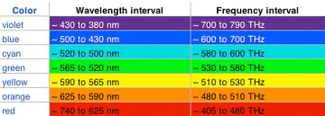

What characteristic does light have?
Light is electromagnetic radiation and has a dual nature consisting of both particles (photons) and waves that result in a changing electric and magnetic field which propagate through space, forming an electromagnetic wave. Light is a transverse wave.
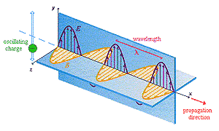
Amplitude -Brightness of the light.
Wavelength (λ) color of the light.
Angle at which it is vibrating - called polarization.
Speed All light waves travel at the speed of light (c ) 792,458 meters per second or 186,282 miles per second.
Frequency - The frequency (number of wavelengths per second) of a light wave may be calculated using the equation: c =fλ
c = speed of light (3x10⁸m/s)
f = Frequency (hz)
λ = wavelength (m)
What factors affect the brightness of a source of light?
The brightness of light is measured as light intensity. The units are watts/meter ² (W/m ² ). The equation used is:
I = p/4πr²
I = Intensity of Light (W/m²)
p= power of light source in watts
r = distance from the light source
The Brightness of light is affected by:
- The power of the light source in watts.
- The distance from the source in meters. Brightness decreases as the square of the distance from the source increases.
- The intervening medium (Air, water, cloud, etc)
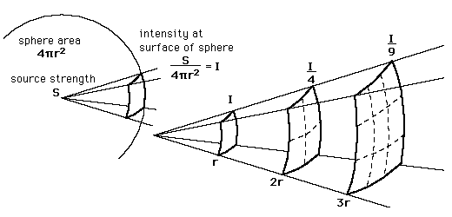
** If distance doubles, intensity goes down by a
Factor of 4**
When is reflected light considered specular and when is it considered diffuse?
- Reflection is the change in direction of an electromagnetic wave at a surface that causes it to move away from the surface.
- The texture of a surface affects how it reflects light.
  - Diffuse reflection is reflection from a rough, texture surface such as paper or unpolished wood.
  - Specular reflection is reflection from a smooth, shiny surface such as a mirror.
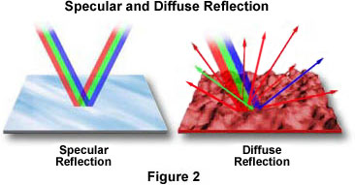

Why does the relationship between Frequency, wavelength, and speed hold for light waves?
The relationship between frequency and wavelength of a light wave hold because all forms of light, or electromagnetic waves, travel at the constant speed of light in a vacuum. c =fλ

What is the law of reflection?
- The law of reflection states that the angle between an incident ray of light(I) and the normal to the mirror’s surface (N) equals the angle between the normal (N) and the reflected light ray(R).
- Angle of incidence - the angle between a ray that strikes a surface and the line perpendicular to that surface at the point of contact.
- Angle of reflection -the angle formed by the line perpendicular to a surface and the direction in which a reflected ray moves.
- The angle of incidence and the angle of reflection are always equal.
- The objects we see are visible only because they reflect light.

RAY DIAGRAM: - Light travels in straight lines in a medium. A ray diagram is an optics diagram that uses imaginary lines (RAYS) to show the straight line path of light.

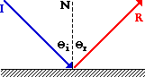
ǿ_{i} = ǿ_{r}

How does the number of images depend on the angle between two flat mirrors?
In this section we deal with flat mirrors.
The reflection formed in a flat mirror is a virtual images of an object, is upright and the same distance from the mirror’s surface as the object is (p_{object}=q_{image}). The reflection is the same height (h=h’) with right to left reversal.
As the angle between two mirrors is increased and decreased, the number of reflected images increases and decreases. At some angles, you will see all complete images. At other angles, you will see some complete images and some parts of images.
A virtual image can never be displayed on a physical surface.
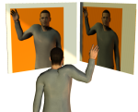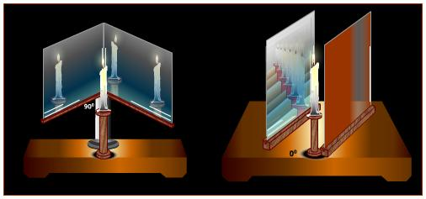

What is an image and how does it differ from an object/source of light?
An image is an optically formed reproduction of an object, such as one formed by a lens or mirror
What is the difference between real and virtual images?
There are two types of image
- Real Image -This is one through which the light rays actually pass and which can be formed on a screen. Examples of real images are the image formed on the film in a camera or on the retina of your eye.
- Virtual Image -This is one through which the rays do not pass; they only appear to come from it. Examples of virtual images are the image formed by a magnifying glass when used to look at a small object and that in a plane mirror. For a real object, the image produced by a plane mirror is virtual and the same distance behind the mirror as the object is in front of it. (See Figure 2).

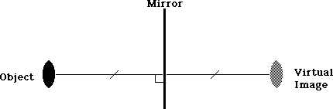
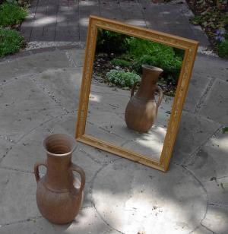

How can focal point be found using ray diagrams?
A focal point is the point on the principle axis of a lens or mirror to which parallel rays of light converge or from which they appear to diverge after refraction or reflection.
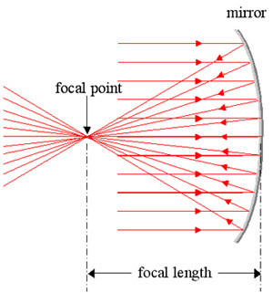

A ray diagram is used to locate the image formed by a mirror using geometry
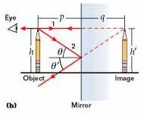
What shapes can optical devices have and how does the shape affect the position, location, orientation and size of the image?
- Concave Spherical Mirror:
- An inwardly curved, mirrored surface that is a portion of a sphere.
- Converges incoming light rays
- Objects close to mirror appear larger than the object.
- Objects far away from the mirror appear smaller than the object.
- Forms real images in front of the concave mirror.
- Used whenever a magnified image is needed (dressing room mirror)
- Principal axis- A line that extends infinitely from the center of the mirror’s surface through the center of curvature.
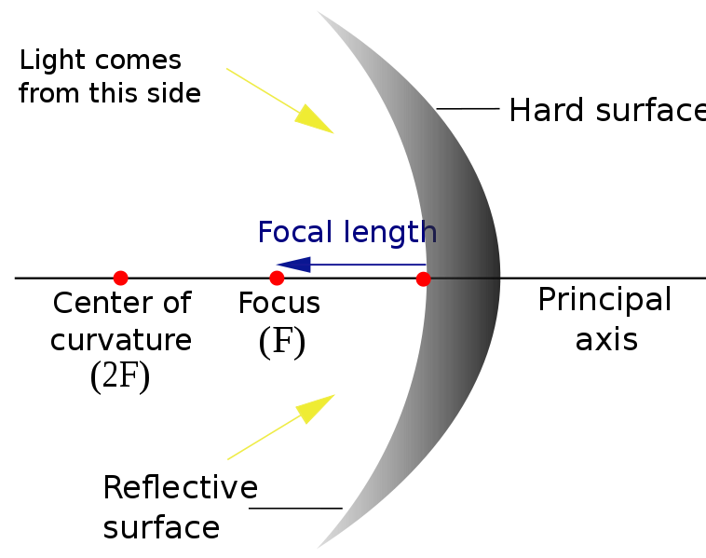

- A convex Spherical mirror:
- An outwardly curved, mirrored surface that is a portion of a sphere.
- Diverges incoming light rays.
- Forms a virtual image that appears behind the mirror
- Used on a car’s passenger side view mirror
- Image appears smaller that the object
- Also called a diverging mirror

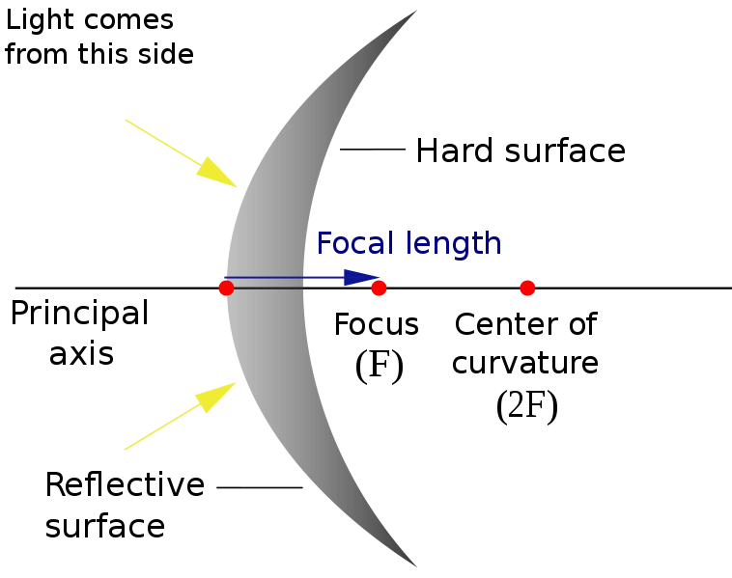
- Parabolic Mirror
- A reflective device used to collect or project energy such as light.
- The parabolic reflector transforms an incoming plane wave traveling along the axis into a spherical wave converging toward the focus. Conversely, a spherical wave generated by a point source placed in the focus is transformed into a plane wave propagating as a collimated beam along the axis.
- Parabolic reflectors are used to collect energy from a distant source (for example incoming star light) and bring it to a common focal point thus correcting spherical aberration found in simpler spherical reflectors.
-Since the principles of reflection are reversible, parabolic reflectors can also be used to project energy of a source at its focus outward in a parallel beam used in devices such as spotlights and car headlights.
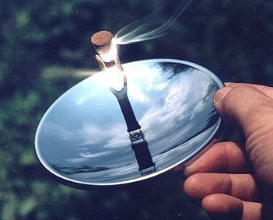

What is the difference between real and virtual images?
Real Image:
- Any time the light rays' energies are capturable.
- The image would be at the focus point of a concave mirror and convex lenses
- You can put your hand or a piece of paper at the focal point and see the image imprinted on it, or in the case of sunlight, get burned from the energies.

Virtual Image:
-flat and convex mirrors and concave lenses do not bring the energies together.
-The image you see of yourself in your bathroom mirror appears to be behind the glass. This makes it a virtual image, not a real one. You see it, but it isn't really there.
-Images can be bigger or smaller than the real object it is viewing.
-Images can be right side up upside down.

What is the difference between parabolic and spherical mirrors?
A parabolic reflector (or dish or mirror) is a reflective device used to collect or project energy such as light, sound, or radio waves. Its shape is that of a circular paraboloid, that is, the surface generated by a parabola revolving around its axis. The parabolic reflector transforms an incoming plane wave traveling along the axis into a spherical wave converging toward the focus. Conversely, a spherical wave generated by a point source placed in the focus is transformed into a plane wave propagating as a collimated beam along the axis.
Parabolic reflectors are used to collect energy from a distant source (for example sound waves or incoming star light) and bring it to a common focal point, thus correcting spherical aberration found in simpler spherical reflectors. Since the principles of reflection are reversible, parabolic reflectors can also be used to project energy of a source at its focus outward in a parallel beam, used in devices such as spotlights and car headlights.
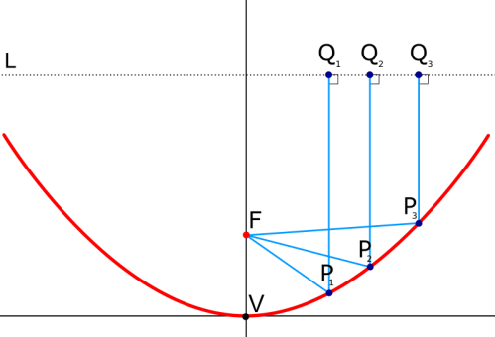
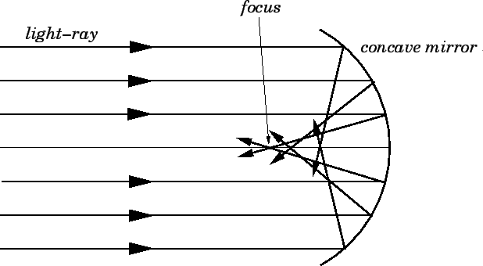
Figure 70: Spherical aberration in a concave mirror.

A spherical mirror is a mirror which has the shape of a piece cut out of a spherical surface. There are two types of spherical mirrors: concave, and convex. The most commonly occurring examples of concave mirrors are shaving mirrors and makeup mirrors. As is well-known, these types of mirrors magnify objects placed close to them.
The most commonly occurring examples of convex mirrors are the passenger-side wing mirrors of cars. These type of mirrors have wider fields of view than equivalent flat mirrors, but objects which appear in them generally look smaller (and, therefore, farther away) than they actually are.
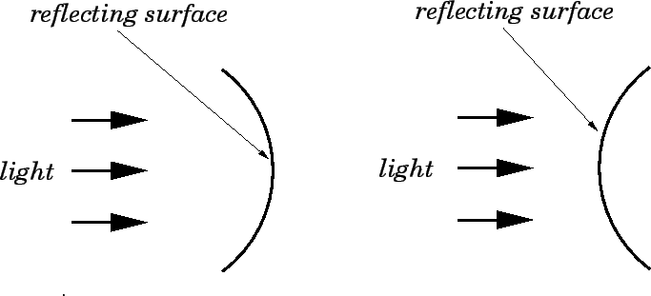
Figure 68: A concave (left) and a convex (right) mirror
Figure 70: Spherical aberration in a concave mirror.

What are the different types of optical devices?
An optical device is a device that creates, manipulates, or measures electromagnetic radiation (mirror, lenses).

What is Snell’s Law?
The bending of light as it travels from one medium to another is call refraction. As a light ray travels from one medium into another medium where its speed is different, the light ray will change its direction unless it travels along the normal.
Refraction can be explained in terms of the wave model of light. The speed of light in a vacuum, c, is an important constant used by physicists. Inside of other mediums, such as air, glass, or water, the speed of light is different and is usually less than c.
The Law of Refraction-The index of refraction for a substance is the ratio of the speed of light in a vacuum to the speed of light in that substance.

- When light passes from a medium with a smaller index of refraction to one with a larger index of refraction (like from air to glass), the ray bends toward the normal.
- When light passes from a medium with a larger index of refraction to one with a smaller index of refraction (like from glass to air), the ray bends away from the normal.
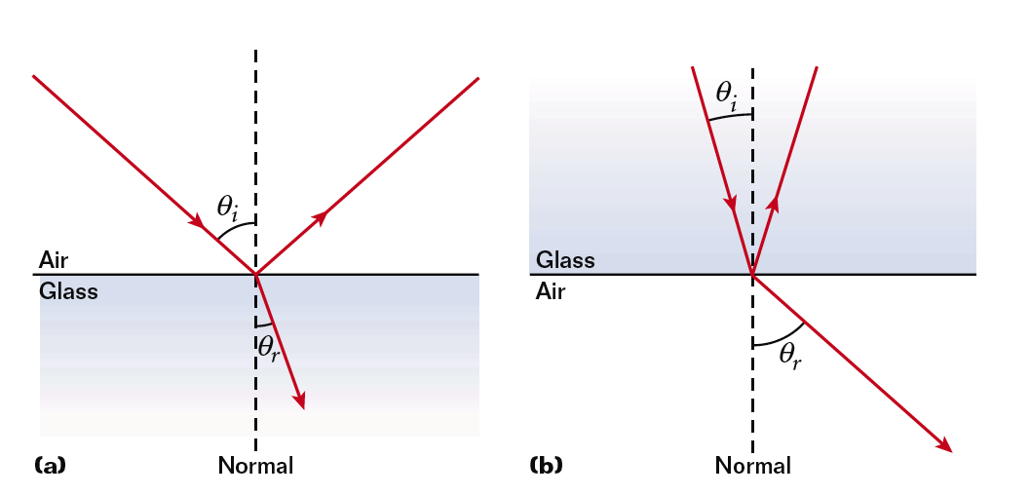
- Objects appear to be in different positions due to refraction.
- Snell’s Law determines the angle of refraction.

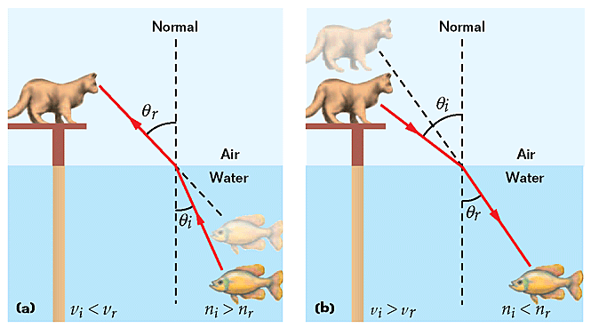

-When you put a pencil in a glass of water and look at it from the side it appears bent. This phenomenon is called refraction.

-When a light ray moves from air into any material the ray will bend (refract) towards the normal because the index of refraction for air is 1.0. All other materials have a higher “n” value.

What is the difference between convex and concave lenses?
- Lens – A transparent object that refracts light rays, causing them to converge or diverge to create an image.
- Converging lens (CONVEX) – Thicker in the middle. Bend light inward. Produce real or virtual images. Light rays converge (Magnifying glass, human eye)

- Diverging lens (CONCAVE) – Thicker at the edge. Bends light outward. Produce virtual image only. Light rays diverge. Reduces the size of the object.
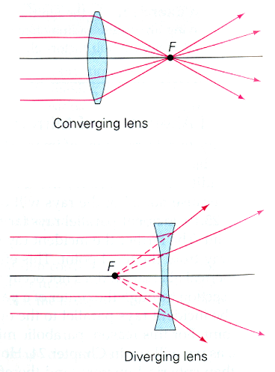

How are colors related to light?
- What happens to light is determined by the object that the wave hits. This will give the object its color.
- Black object -All the wavelengths of light hitting that object are absorbed; no light is reflected.
- Solid objects, for the most part, will reflect light.
- Transparent objects will transmit light through them. Clear window
- Translucent- permitting light to pass through but diffusing it so that persons, objects, etc., on the opposite side are not clearly visible: Frosted window glass is translucent but not transparent.
- Additive primary colors -red, green, and blue produce white light when combined.
- Light of different colors can be produced by adding light consisting of the primary additive colors (red, green, and blue).
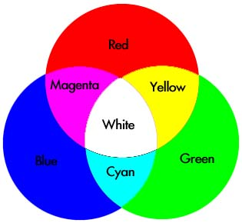

When two beams of coherent light are shining on the same sheet of white paper, darkness appears where the crest of one wave overlaps the trough of the other.

Interference effects such as the one listed above were first seen in the 1800’s and revealed the wave nature of light.

Photoreceptors, or Cone cells, are located in the retina of the eye and are responsible for color vision. They respond to Red, Green, and Blue light. (RGB)

What is polarization?
Light has properties both as a particle and as an electromagnetic wave. Since light waves have the ability to vibrate in multiple directions, it is possible to shut out some of these directions, thus producing polarized light.
The simplest way to polarize light is via the use of a Polaroid filter. A Polaroid filter is made up of material which can block one of the directions of light (either up and down or left and right). As a result, a Polaroid filter removes half of the light's waves.
Light can also be polarized via other means. When light reflects off of non-metallic surfaces, polarized light will emerge. If the polarization is extreme, "glare" will be observed.
