Name: __________________________ Date: __________ Period: _____________

Reflection and Refraction of Light

Section 22.1 The Nature of Light

1. During the Apollo XI Moon landing, a retroreflecting panel was erected on the Moon’s surface. The speed of light can be found by measuring the time it takes a laser beam to travel from Earth, reflect from the panel, and return to Earth. If this interval is found to be 2.51 s, what is the measured speed of light? Take the center-to-center distance from Earth to Moon to be 3.84 × 10⁸ m. Assume that the Moon is directly overhead and do not neglect the sizes of the Earth and Moon.

2. Figure P22.2 shows the apparatus used by Armand H. L. Fizeau (1819–1896) to measure the speed of light. The basic idea is to measure the total time it takes light to travel from some point to a distant mirror and back. If d is the distance between the light source and the mirror, and if the transit time for one round-trip is t, then the speed of light is c = 2d/t. To measure the transit time, Fizeau used a rotating toothed wheel, which converts an otherwise continuous beam of light to a series of light pulses. The rotation of the wheel controls what an observer at the light source sees. For example, assume that the toothed wheel of the Fizeau experiment has 360 teeth and is rotating at a speed of 27.5 rev/s when the light from the source is extinguished—that is, when a burst of light passing through opening A in Figure P22.2 is blocked by tooth B on return. If the distance to the mirror is 7 500 m, find the speed of light.

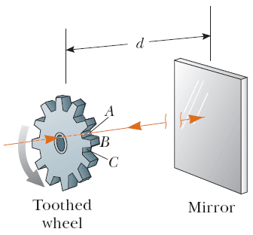
Figure P22.2 (Problems 2 and 3)

3. In an experiment designed to measure the speed of light using the apparatus of Fizeau described in the preceding problem, the distance between light source and mirror was 11.45 km and the wheel had 720 notches. The experimentally determined value of c was 2.998 × 10⁸ m/s. Calculate the minimum angular speed of the wheel for this experiment.

4. Albert A. Michelson very carefully measured the speed of light using an alternative version of the technique developed by Fizeau. (See Problem 22.2.) Figure P22.4 shows the approach Michelson used. Light was reflected from one face of a rotating eight-sided mirror towards a stationary mirror 35.0 km away. At certain rates of rotation, the returning beam of light was directed toward the eye of an observer as shown. (a) What minimum angular speed must the rotating mirror have in order that side A will have rotated to position B, causing the light to be reflected to the eye? (b) What is the next-higher angular velocity that will enable the source of light to be seen?

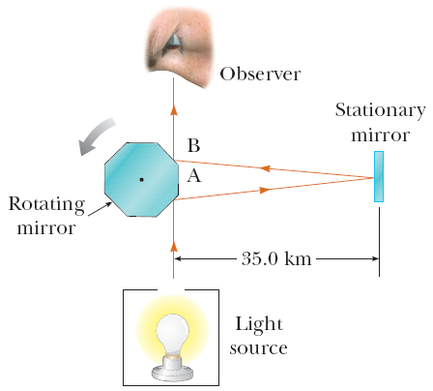
Figure P22.4

5. Figure P22.5 shows an apparatus used to measure the distribution of the speeds of gas molecules. The device consists of two slotted rotating disks separated by a distance d, with the slots displaced by the angle θ. Suppose the speed of light is measured by sending a light beam toward the left disk of this apparatus. (a) Show that a light beam will be seen in the detector (that is, will make it through both slots) only if its speed is given by c = ωd/θ, where ω is the angular speed of the disks and θ is measured in radians. (b) What is the measured speed of light if the distance between the two slotted rotating disks is 2.500 m, the slot in the second disk is displaced 1/60 of 1 degree from the slot in the first disk, and the disks are rotating at 5 555 rev/s?

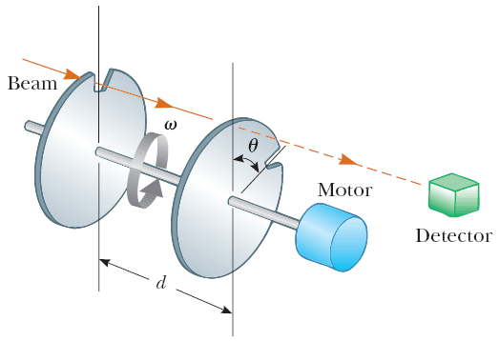
Figure P22.5

REFRACTION OF LIGHT SECTION:

6. The two mirrors in Figure P22.6 meet at a right angle. The beam of light in the vertical plane P strikes mirror 1 as shown. (a) Determine the distance the reflected light beam travels before striking mirror 2. (b) In what direction does the light beam travel after being reflected from mirror 2?

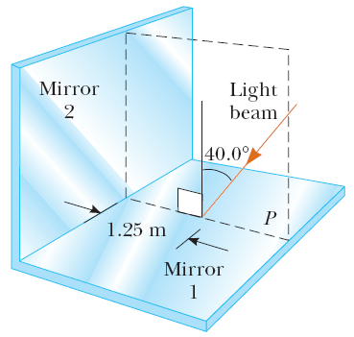
Figure P22.6

7. An underwater scuba diver sees the Sun at an apparent angle of 45.0° from the vertical. What is actual direction of the Sun?

8. Light is incident normal to a 1.00-cm layer of water that lies on top of a flat Lucite® plate with a thickness of 0.500 cm. How much more time is required for light to pass through this double layer than is required to traverse the same distance in air (n_{Lucite} = 1.59)?

9. A laser beam is incident at an angle of 30.0° to the vertical onto a solution of corn syrup in water. If the beam is refracted to 19.24° to the vertical, (a) what is the index of refraction of the syrup solution? Suppose the light is red, with wavelength 632.8 nm in a vacuum. Find its (b) wavelength, (c) frequency, and (d) speed in the solution.

10. Light containing wavelengths of 400 nm, 500 nm, and 650 nm is incident from air on a block of crown glass at an angle of 25.0°. (a) Are all colors refracted alike, or is one color bent more than the others? (b) Calculate the angle of refraction in each case to verify your answer.

11. Light of wavelength λ₀ in a vacuum has a wavelength of 438 nm in water and a wavelength of 390 nm in benzene. (a) What is the wavelength λ₀? (b) Using only the given wavelengths, determine the ratio of the index of refraction of benzene to that of water.

12. Light of wavelength 436 nm in air enters a fishbowl filled with water, then exits through the crown-glass wall of the container. Find the wavelengths of the light (a) in the water and (b) in the glass.

13. The light emitted by a helium–neon laser has a wavelength of 632.8 nm in air. As the light travels from air into zircon, find (a) its speed in zircon, (b) its wavelength in zircon, and (c) its frequency.

14. A flashlight on the bottom of a 4.00-m-deep swimming pool sends a ray upward and at an angle so that the ray strikes the surface of the water 2.00 m from the point directly above the flashlight. What angle (in air) does the emerging ray make with the water’s surface?

15. How many times will the incident beam shown in Figure P22.15 be reflected by each of the parallel mirrors?

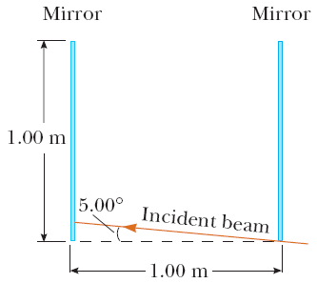
Figure P22.15

16. A ray of light strikes a flat 2.00-cm-thick block of glass (n = 1.50) at an angle of 30.0° with the normal (Fig. P22.16). Trace the light beam through the glass, and find the angles of incidence and refraction at each surface.

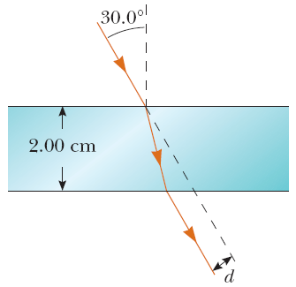
Figure P22.16 (Problems 16, 17, and 18)

17. When the light ray in Problem 16 passes through the glass block, it is shifted laterally by a distance d (Fig. P22.16). Find the value of d.

18. Find the time required for the light to pass through the glass block described in Problem 17.

19. The light beam shown in Figure P22.19 makes an angle of 20.0° with the normal line NN’ in the linseed oil. Determine the angles θ and θ’. (The refractive index for linseed oil is 1.48.)

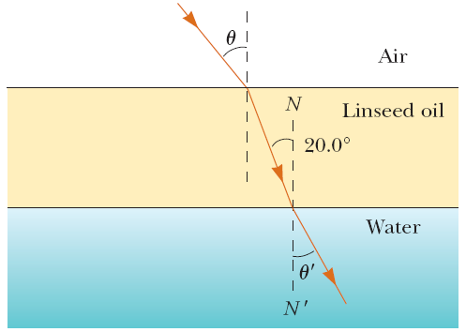
Figure P22.19

20. A submarine is 300 m horizontally out from the shore and 100 m beneath the surface of the water. A laser beam is sent from the sub so that it strikes the surface of the water at a point 210 m from the shore. If the beam just strikes the top of a building standing directly at the water’s edge, find the height of the building.

21. Two light pulses are emitted simultaneously from a source. The pulses take parallel paths to a detector 6.20 m away, but one moves through air and the other through a block of ice. Determine the difference in the pulses’ times of arrival at the detector.

22. A narrow beam of ultrasonic waves reflects off the liver tumor in Figure P22.22. If the speed of the wave is 10.0% less in the liver than in the surrounding medium, determine the depth of the tumor.

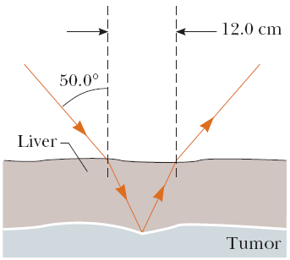
Figure P22.22

23. A beam of light both reflects and refracts at the surface between air and glass, as shown in Figure P22.23. If the index of refraction of the glass is n_{g}, find the angle of incidence, θ₁, in the air that would result in the reflected ray and the refracted ray being perpendicular to each other. [Hint: Remember the identity sin(90° − θ) = cos θ.]

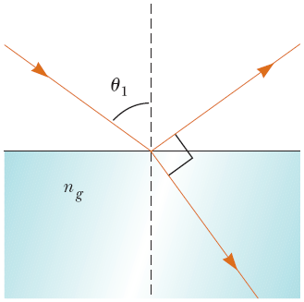
Figure P22.23

29. Calculate the critical angles for the following materials when surrounded by air: (a) zircon, (b) fluorite, and (c) ice. Assume that λ = 589 nm.

30. For 589-nm light, calculate the critical angle for the following materials surrounded by air: (a) diamond and (b) flint glass.

31. Repeat Problem 30, but this time suppose that the materials are surrounded by water.

32. A beam of light is incident from air on the surface of a liquid. If the angle of incidence is 30.0° and the angle of refraction is 22.0°, find the critical angle for the liquid when surrounded by air.

33. A plastic light pipe has an index of refraction of 1.53. For total internal reflection, what is the minimum angle of incidence if the pipe is in (a) air? (b) water?

