Name: _________________ Date: ___________ Period: _________

Forces Virtual Lab: LAB 6
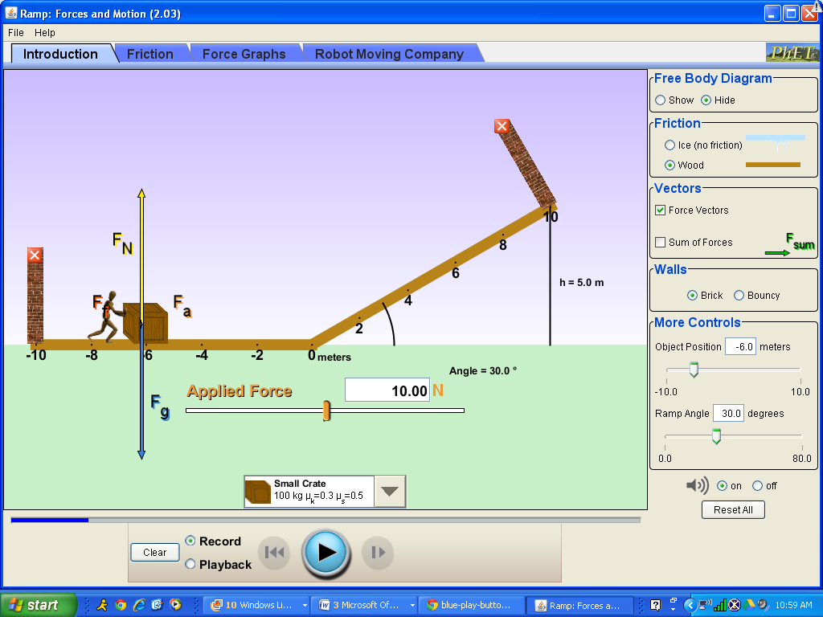

Go to http://phet.colorado.edu/en/simulation/ramp-forces-and-motion

- You will be starting with a crate that has a mass of 100 kg and a coefficient of sliding friction of 0.3 and a coefficient of static friction of 0.5 (These values are already set)

Perform the Following:

1. Draw the Free Body Diagram before you apply any force.

2. Add 10 N of applied force, and push the play button and record what happens. Include a free body diagram showing all the forces.

3. Add 100 N of applied force and push the play button. What changed?

4. Calculate how much force would be required to move the box. Show your work here. Enter the number you calculate as the applied force. Try it out. What happened?

5. As the crate from #4 moved, what happened as it moved up the ramp? Show the free body diagram while the crate is on the ramp. What are the two forces working against the applied force on the ramp in this case?

6. a. Reset all. Predict what you think would happen to if you increased the angle.
b. Set the applied force to the value you used from step 4 with a larger angle
selected (>30) and Press “play”.
c. What actually happened? Explain why you saw what you saw. (Look at the equations
That involves angles)

7. Reset all. Repeat question#6 with a smaller angle (<30). What actually
happened? Explain why you saw what you saw. (Look at the equations that involves
angles)

8. a. Using the “object position control”, place the crate in the middle of the ramp.
Make sure the applied force is “0”.
b. Set the angle at 20º.
c. Hit the play button.
d. What is true about the force due to gravity and the friction force, as related to
the applied force if the crate does not go down the ramp?
e. Using the “ramp angle control”, slowly increase the angle until the block JUST
starts to move. (make sure “play” is pressed).
f. Use the angle from step “e” to calculate the coefficient of static friction (μ_{s}) and
compare the value to the given value for μ_{s} for the crate shown at the bottom of
simulation the screen. SHOW ALL WORK HERE.

9. a. Press RESET ALL.
b. Calculate how much applied force you would need move the crate at constant speed up the 30º ramp. Show your work below and record your answer to the tenth of a Newton (Hint: Remember it’s moving now, so which μ do you need to use? What is Net force equal to here? Review your answer to #5)

10. a. Go to the “Forces Graph” tab.
b. Reset all.
c. Input your applied force from step #9
d. Push play. Stop the crate before it crashes into the wall.
e. Is your net force show on the simulator = 0?
f. What does that tell you about the motion of the crate?

11. a. Place the block at the top of the 30º ramp (Position = 8.9 m) using the position
control box.
b. Calculate the net force (F_{net}) on the block down the ramp? (Hint: 2 forces are
present and there is no applied force by the person). Show your calculation
below.
c. What is the acceleration of the block down the ramp?(F_{net}=ma)(Include your
calculation).
d. What would be the final velocity of the block at the bottom of the ramp
(V_{f}² =V_{i}² + 2a∆x)?

12. What force is acting on the crate once it hits the flat part at the bottom of the ramp? What is the magnitude and direction of that force?

13. What will be the acceleration of the crate on the flat part at the bottom of the ramp? (F_{net}=ma)

14. Calculate how far the crate should slide at the bottom. Try it out. How did your calculation compare to the applet result? (V_{f}² =V_{i}² + 2a∆x)

